Name: Rodrigo Proença de Oliveira
E-mail: rodrigopoliveira@tecnico.ulisboa.pt
Institution: Instituto Superior Técnico (Universidade de Lisboa)
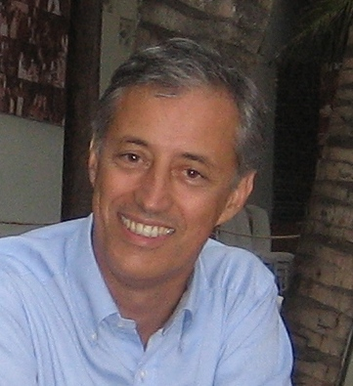 | Rodrigo Proença de Oliveira is a civil engineer with a MSc and PhD degrees in Water Resources Management and Planning from Cornell University, USA. His activity covers research, teaching and private consulting in water resources management and planning, with a special interest in climate change. He has coordinated and participated in several hydrological studies and water management plans, extensively using mathematical modelling and information system tools, including geographic information systems. Since 1998 he has been active on the assessment of climate change impacts on water resources and on the design of adaptation strategies. He also supports the Portuguese Environment Agency in managing the Portuguese Emission Trading Registry. He was the president of the Portuguese Water Resources Association for two years and member of its direction bodies for 8 years.
References (max. 5 relevant references)
Santos, C.A.; Almeida, C.; Ramos, T.B.; Rocha, F.A.; Oliveira, R.P.; Neves, R.; 2018. Using a Hierarchical Approach to Calibrate SWAT and Predict the Semi-Arid Hydrologic Regime of Northeastern Brazil, Water, 8/2018.
Diaz-Redondo, M.; Egger, G.; Marchamalo, M.; Damm, C.; Oliveira, R.P.; Schmitt, L.; 2018. Targeting lateral connectivity and morphodynamics in a large river?floodplain system: The upper Rhine River, River Research and Applications, May 2018.
Pombo, S.; Oliveira, R.P.; 2014. Evaluation of extreme precipitation estimates from TRMM in Angola, Journal of Hydrology, Volume 523, April 2015, Pages 663-679.
Pombo, S., Oliveira, R.P.; Marques, A., 2014. Validation of remote-sensing precipitation products for Angola, Meteorological Applications (2014), November 2014.
Oliveira, R.P.; Loucks, D.P.; 1997. Operating rules for multi-reservoir systems. Water Resources Research, 33(4):839-852, April 1997.

This project has been funded with support from the European Commission. This publication reflects the views only of the author, and the Commission cannot be held responsible for any use which may be made of the information contained therein.

